1)how to generate html

Create index.html file and type html. You will get some suggestions, select these suggestions. And html code will be autopopulayed.

2) how to have mutiple files tab

If you click on file single time. it will open in a tab. Now if you gain click on some other file, it open in place of first file.

If you want to open multiple files then open file by double click

3)how to open multiple files at same time(view -> split editor)

View -> edit layout

b) how to see files behind each other (view -> toogle editor group layout)

4) how to open bottom screen (click on status bar at bottom)

5) how to open multiple terminals(cmd)

6) hw to open command plete(view -> open command pellet)-

a)how to chnage color(in cmmand pellet search preference:color theme)

b)how to change icon(preferences:command pellete, search- File Icon theme)

here we have 3 options there, but we can also install additional themes for icon.we will add one here. In extensions- serach maretial icon. install that theme. Now you will see 4 options instead of 3 in previous menu.

When files are opened in multiple tabs, little dots above them signifies that we have not saved changes.

7)we can hover over js functions to see their syntax

8) how to go into function defination, peek definations.

Right click on function and you will see these options.

Go to definition takes you to function definition.

While peek definition opens up the mini editor at same place.it will also tell the file and lime number where your function is defined. You can even make changes to function. but you have to save your code and run it again.

then it video it was talked tht angular essenil is extension for angular.

9)how to change keyboard shortcuts

Go to command pallete. Type shortcut. Then open keyboard shortcuts. There you can type shortcuts to see what it does-

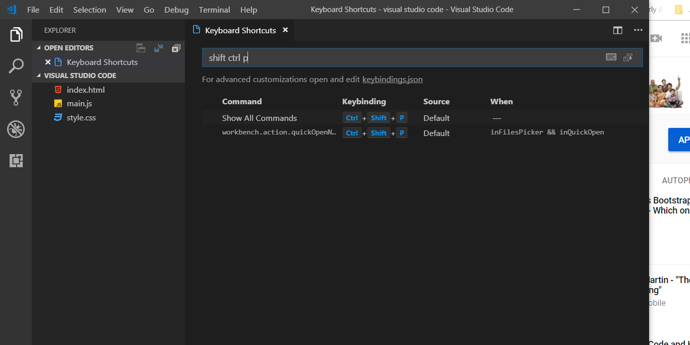

Now you can click on key to change shortcut. You can also serach a shortcut by its description.

This docs has some useful keyboard shortcuts-

<https://academind.com/learn/web-dev/visual-studio-code-introduction/>

10) how to type at many places at same time by using ctrl key.

Click where you want to type, now if you want to type on somewhere else at same time, type press ctrl and click there and so on. You can type n number of places like this.

11)when we select span, then all span in file are highlighted. If you press **ctrl+d,** then next span will be selected and so on. Now if you type, in all your selected regions will be typed.

If you want to know what this feature is called. Go to shortcuts section(by command pellete as shown above) nd type **ctrl d**  like this-

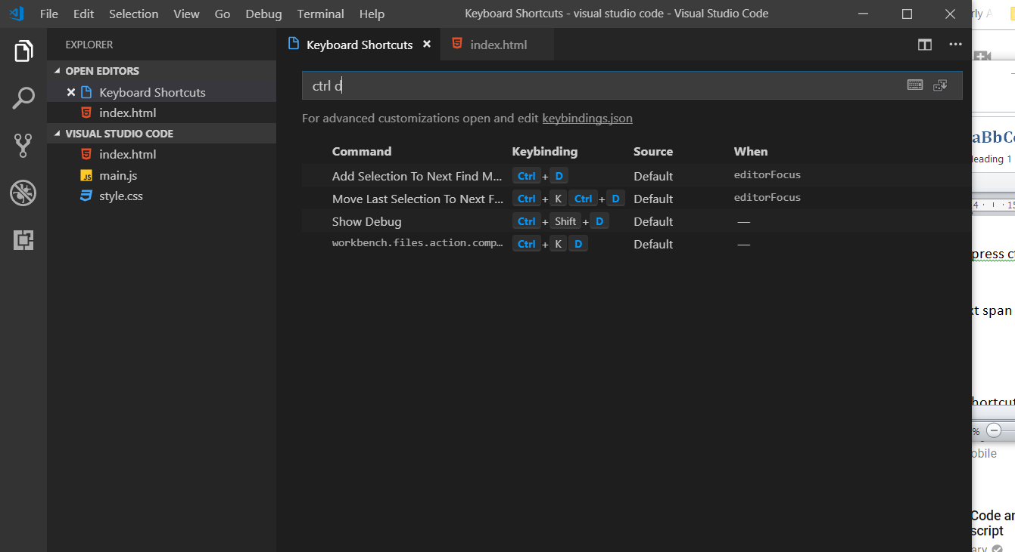

12) if you want to format text in studio – shift+alt+f (to find it search formt in keyboard shortcuts in command pellet). This does not work for css by the way. Look if that works for programming language you are using . if not, the look for some extension. with that it should be fine in the end.

**13) to switch between files. Press ctrl+p. it will show you list of files. Keep ctrl key press, pressing p will take you to different files. Release ctrlkey and selected file will be opened.**

14) to switch between projects , press ctrl+r

If you want to know about shortuts, go to help -> keyboard shortcut refrence, it gives you nice overview.

Now let’s see about settings. Open settings. Go to command pallet, search settings and then open **prefrences: settings.** Here we will see a file, that file is not editable. If you want to change settings, you need to add that setting to usersetting or workspace setting. Both of these are at right hand side. You can search for items in settinngs.

1. To open chnge welcome page, search welcome in settings. Click on pencil at left hand side, to see options. If you any change here, same will be updated in user settings , which is shown on right.
2. We can also change open editors. In settings serch – explorer.open there we will have this option-
3. "explorer.openEditors.visible": 9

Now click on pencil on left side and select “copy to settings”. Now this property will be moved to user.settings file. there if you set property to 0. Then you wnt see any open editors.

1. Search file.auto.
2. Here we have these 2 properties-
3. "files.autoSave": "off",

"files.autoSaveDelay": 1000

These are options that allow you to customize the saving behaviour of visual studio code. When we opened settings on right hand side we can see tab having 2 files. Usersettings and workspacesettings. Workspace settings file is empty while user settings has some of options integrated. This is important core concept of visual studio code now- User setting applies to each instance of code you open on your system. So whenever you open visual studio code these settings will be applied, but there is one exception. This exception is workplace settings. If you define workspace settings, these will override your users settings. if I change some settings in workspace settings, then that setting will override user settings only if I open that same project, in whih I changed work space settings. So this is thing to keep in mind in case of userSettings and workspace settings. Here we changed the zoom level setting for one project and saw that when we open ther projects that setting is not applied.

There is another cool feature about workspace settings. Lets say we have opened project1 in code. Go to file and select **save workspace as** option. Give name to your workspace.now close visual studio code. Now go to path where you saved workspace, double click on it. Youwill see that project 1 is opened in code. Now go to file menu and select  **add folder to workspace.** Now lets say select project 2 folder. now we have both thses projects in our workspace.Now you can see that both project 1 and project are opened in same vs code instance, even though they do not have any relation between them. Now our workspace settings will be applied to whole workspace. That means project 2 will also have workspace settings. Also when you will open a workspace, both og thee folders will be opened in same instance of vs code. You can sue it to open front end and backend code , which may be on different locations. Now here all folders in a workspace will have same workspace settings applied to them. This is cool feature which can make life lot easier, so make sure to dive into that.

You can aslo check official docs if you want to dive deeper into visual studio code.